|  |  |
| --- | --- |
| **#** | **Release Features** |
| 1 | PFM Report Odata project development |
| 2 | Synchronize Project from Portfolio items |
| 3 | FM Report Performance optimization |
| 4 | Directly jump into "Project Team" page from portfolio item UI. |

1. PFM Report Odata project development

Odata Project:

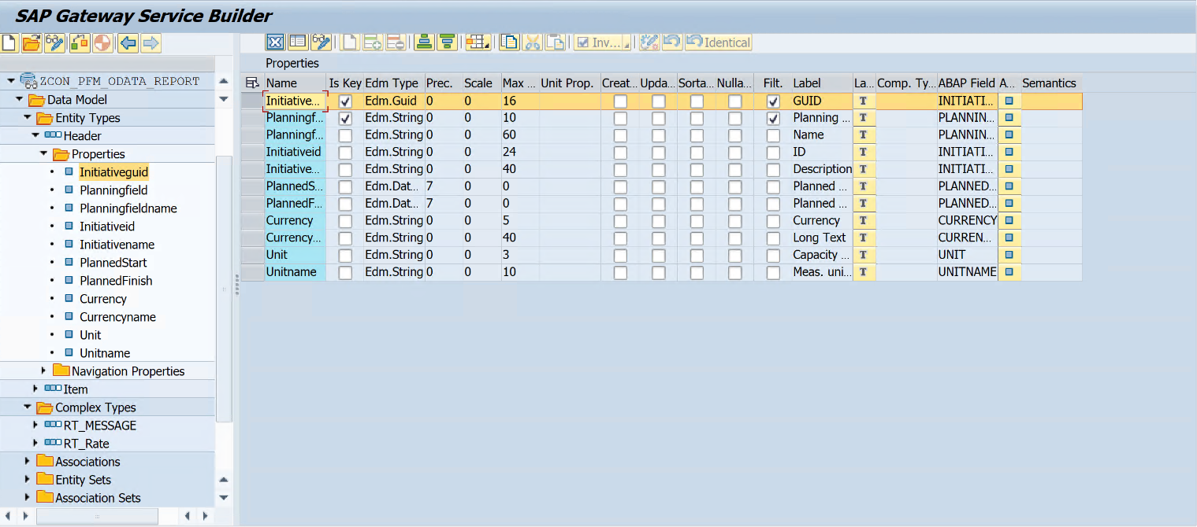

Oata Class:

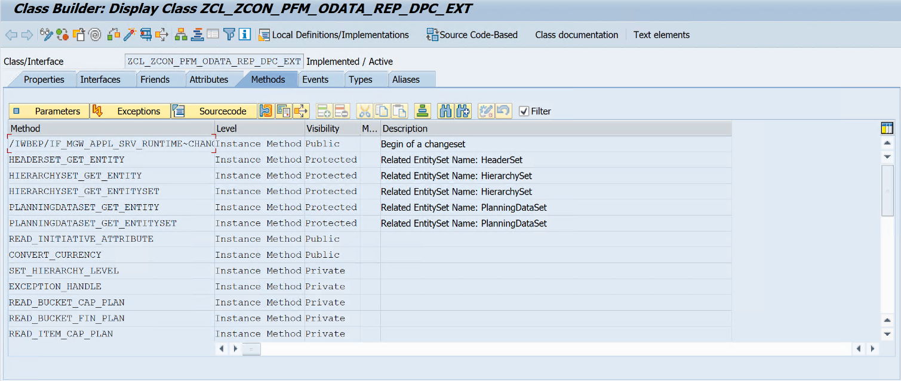

1. Synchronize Project from Portfolio items

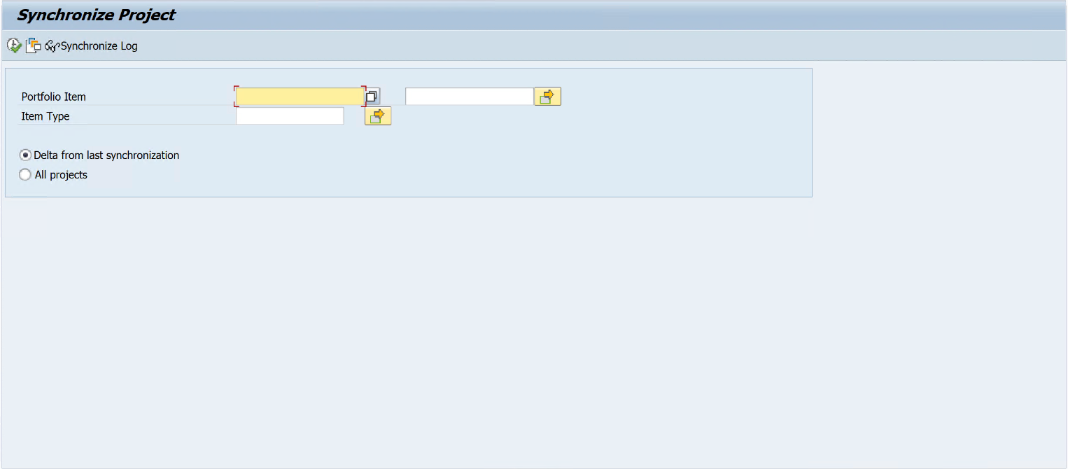

Function Module:

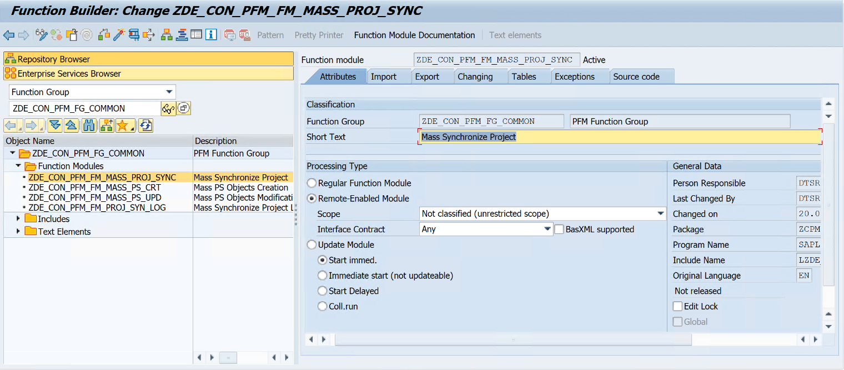

1. FM Report Performance optimization

Fields adjustment:

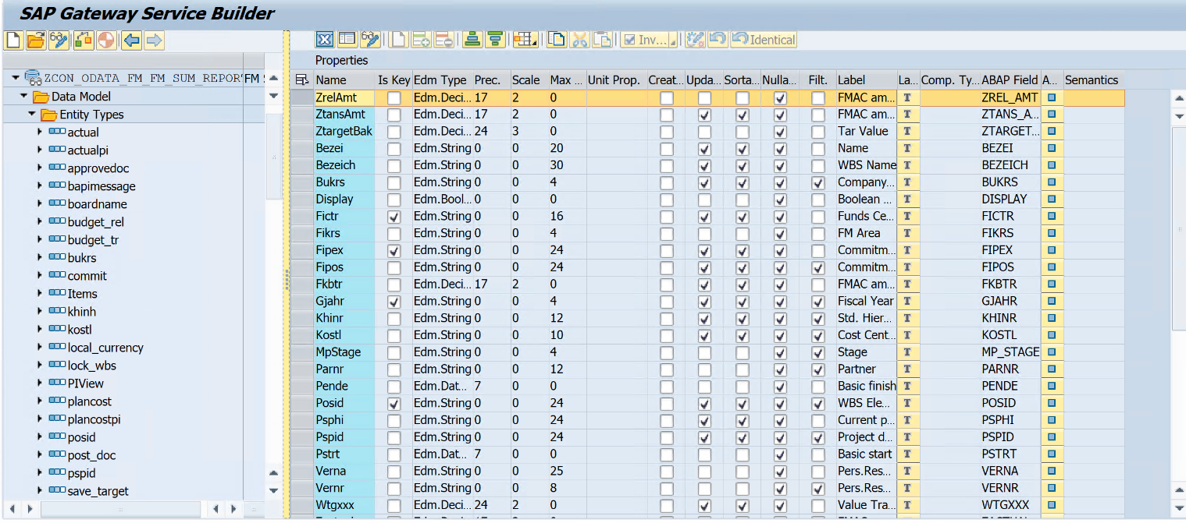

Add drilldown identifier check:

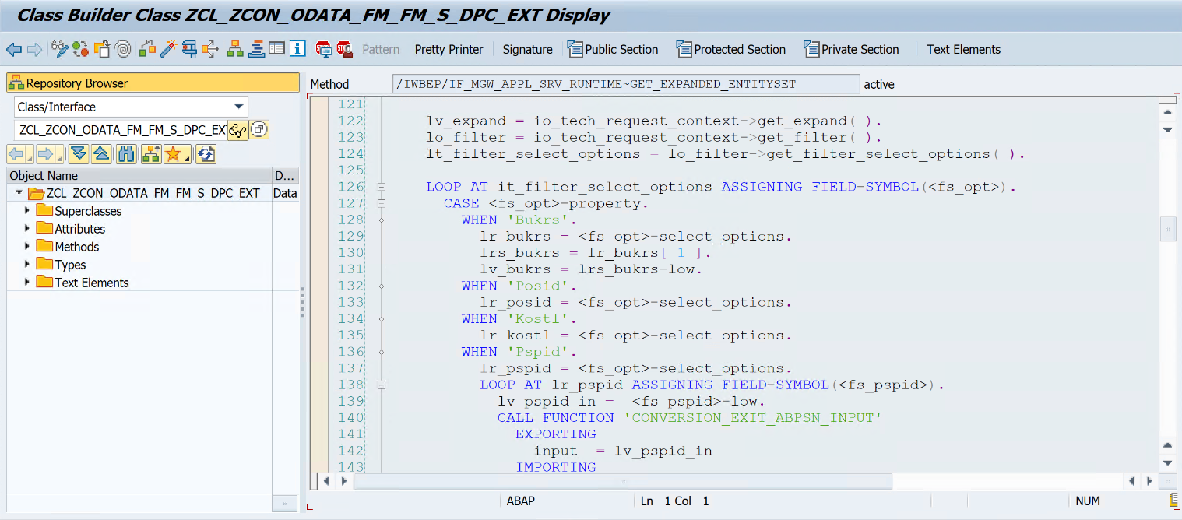

Processing logic:

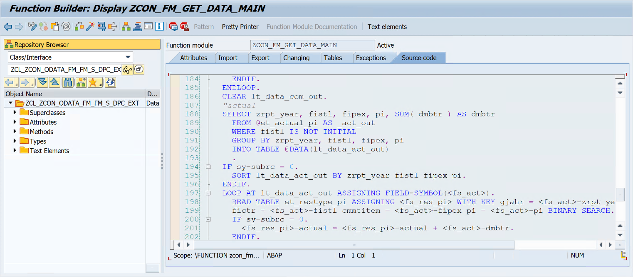

1. Directly jump into "Project Team" page from portfolio item UI.

